## 

**SOFTWARE REQUIREMENTS SPECIFICATION AND**

**SOFTWARE DESIGN SPECIFICATION**

**REPORT**

**IS 2102**

**Group: IS-10**

**Team Inoview**

**Table of contents**

**Group Details**

**Details of Project Supervisor, Mentor and Client**

**Abstract**

**1.0 Introduction**

**1.1. Purpose**

**1.2. Acronyms and abbreviations**

**1.3. Domain description**

**1.4. Current system**

**1.4.1. Stakeholders**

**1.5. Limitations of the current system**

**1.6. Proposed solution**

**1.7. Goals and objectives**

**1.8. Product Scope**

**1.8.1. In-scope**

**1.8.2. Out-of-scope**

**1.9. Assumptions**

**1.10. Constraints and limitations**

**1.11. Work distribution among the group members and individual contribution**

**2.0 Feasibility Study**

**2.1. Economic feasibility**

**2.2. Operational feasibility**

**2.3. Ethical feasibility**

**2.4. Technical feasibility**

**2.5. Risk feasibility**

**2.6. Resource feasibility**

**2.7. Schedule feasibility**

**3.0 Deliverables**

**4.0 Requirements**

**4.1. Stakeholders**

**4.1.1. Administrator**

**4.1.2. Receptionist**

**4.1.3. Student**

**4.1.4. Teacher**

**4.1.5. Parent**

**4.2. Functional Requirements**

**4.3. Nonfunctional requirements**

**4.4. Use cases and Use case diagrams**

**4.5. Use case narratives**

**5.0 Proposed system architecture**

**5.1. High Level Architecture (Three-tier architecture)**

**5.2. Layers and responsibilities**

**5.3. Component Interactions**

**6. 0 System Design**

**6.1. Class Diagram**

**6.2. Sequence Diagrams**

**6.3. Activity Diagrams**

**6.4. Database Designs**

**6.4.1. Entity Relationship Diagram (ERD)**

**7.0 Interfaces**

**7.1. User Interface Flow Diagrams**

**7.2. User Interface Mockups**

**Group Details**

Group: IS-10

|  |  |  |  |  |
| --- | --- | --- | --- | --- |
| No. | Name | Registration no. | Index no. | Signature |
| 1 | H. B. P. Hathurusingha | 2017/IS/031 | 17020311 |  |
| 2 | H. A. P. C. J. Jayathilaka | 2017/IS/038 | 17020387 |  |
| 3 | K. D. H. Chamika | 2017/IS/016 | 17020166 |  |
| 4 | M. S. Mushtaq | 2017/IS/055 | 17020557 |  |

**Project supervisor, mentor and client details**

* **Project supervisor**

Mr. Rangana Jayasanka

* **Mentor**

Ms. Hamsavasani

* **Project client**

mazzSolutions Galle

Owned by Mr. Ilthizam Imtiyas

**Abstract**

In this software requirements specification we focus on the issues faced by our client while using a manual system. We analyzed the inefficiency in registration and payment handling and keeping records of the people involved with the institute. With this web application teachers and students can interact with each other and staff can execute tasks efficiently.

1. **Introduction**
   1. **Purpose**

This documentation provides description on the requirements of **Southern Institute of Galle** which is an educational institute providing tuition for students from grade 6 to Advanced Level (A/L). First we will take a look at the limitations of the manual system currently used at the institute. Then we will evaluate the proposed system with its scope, goals, objectives, limitations and constraints. In this document system’s Feasibility, requirements, architecture, design and interfaces of the proposed system will also be discussed. The proposed system’s design will be described with the aid of diagrams.

* 1. **Acronyms and Abbreviations**

● **HTML - Hypertext Markup Language**,standard markup language for creating web pages.

● **CSS - Cascading Style Sheets**, simple design language intended to simplify the process of making web pages presentable.

● **SQL - Structured Query Language**, standard language for storing, manipulating and retrieving data from databases.

● **MySQL -** MySQL is an open source RDBMS (Relational Database Management System) that uses SQL (Structured Query Language).

● **PHP - Hypertext Preprocessor**, server scripting language, and a powerful tool for making dynamic and interactive web pages.

● **jQuery -** jQuery is an open source JavaScript library that simplifies the process of adding advanced functionality to web projects.

● **ERD - Entity Relationship Diagram**

● **IDE - Integrated Development Environment**, software suite that consolidates the basic tools developers need to write and test software.

* **Code Igniter-** Code Igniter is an open source software rapid development framework, for use in building dynamic web sites with PHP.
* **SRS -** Software Requirements Specification
* **UI -** User Interface
* **CRUD -** In computer programming, create, read, update, and delete are the four basic functions of persistent storage.

* 1. **Domain description**

Southern Institute in Galle is an educational institute which provides valuable education to school students in Galle district as well as setting the right path for their future success. The institute offers tuition classes for students from grade 6 to A/L, throughout the week. Qualified and experienced teachers are conducting classes.

**1.4. Current system**

Current System is based on manual maintenance of all records relevant to the students, staff and payments which is highly inefficient. In order to join classes, students have to visit the class and see available classes or call the institution. Also the scheduling system which assigns students and staff to classes is not well maintained, leading financial mismanagement and confusion. Payment gathering from students and teachers is not done in an efficient manner and hence hard to determine those who have not made the payment in due time.

The proposed web application will automate all manual processes together with few more functionalities which will help to gain more attraction among students and teachers alike and ease the effort of maintaining records.

* + 1. **Stakeholders**

Stakeholders of the current system are

* Admin
* Receptionist
* Teacher
* Student
* Parent

Out of the mentioned stakeholders Admin and Receptionist are primary actors while Student, Teacher and Parent are secondary actors.

* 1. **Limitations of the current system**

Some of the limitations that were noticed in the current system are given below.

**Inefficient scheduling and hall management system**

The scheduling and hall management is done manually hence there is no proper way of keeping track of any changes in class schedule or arrangement of extra classes. One crucial limitation of the current system is that any changes in schedule or hall allocation has to be informed to the particular students or teachers manually by contacting each one of them.

**Inefficient payment handling**

Payment handling is not done in a very efficient manner in the current system. Since all payments are gathered by the receptionist and their details are maintained manually, processing this information to identify who have not made payments in due time can be tough. This is a major limitation in the system.

**Inefficiency in registration**

In the current system student and staff registration is done manually, all personal details, the classes attended and classes taught are recorded manually. It is difficult to keep track of how many students attend a particular class and quickly access details about a student.

**Inefficient maintenance of student and staff details**

Students are registered by filling an application paper. Often these student registration forms are misplaced hence needs to handout applications every time student details are needed to be collected. Staff details are also collected manually and there is no proper way of storing and maintaining them.

**Limitation in tracking student progress**

Since there is little interaction between the student and the teacher it is hard to keep track of student progress. The manual system currently in effect does not allow for report generation or analysis of student progress.

**Distribution of printed material**

The current system distributes the assignments and gradings in printed paper to all students of the institute. The printing cost is high and also there is the chance of misplacing the documents.

* 1. **Proposed solution**

As a solution to the limitations of the current system discussed above, a web application system is introduced for Southern Institute. The proposed solution will have the following functionalities,

* Online learning management system
* Registration system
* Staff management system
* Payment system
* Hall management system

The proposed solution mainly provide functionalities for registration, payment and the process of allocating students to courses. In addition to that it allows to manage details of those involved with the system.

There are four main users of the system, admin, receptionist, teachers and students. Users are required to log in to the system to view functionalities specific to them.

Once successfully logged in, users will be redirected to a customized landing page showing their own dashboard based on the type of user. From there the users can perform functionalities that belongs to the particular user type.

The system also provides other required functionalities such as hall management at the institute, sending payment reminders to students and notifying parents via text messages in case a student does not show up to class within an hour.

* 1. **Goals and objectives**

**Goal**

Creating a web based system for the students and staff to maintain proper records, organize the system while enabling better interaction between students and teachers.

**Objectives**

* Re-engineering the business processes using technological solutions.
* Gaining competitive advantage over similar institutes.
* Automate the manual system maintained to track student attendance.
* Maintain an automated system to keep parents notified.
* Providing a web based platform for teacher-student interactions.
* Hall management and scheduling classes efficiently to reduce time wastage.
  1. **Product Scope**

**1.8.1. In-scope**

The below functionalities are intended through this web application

* Staff management
* Hall management
* Maintaining student attendance
* Payment management system
* System to maintain student and staff data
* Automatic notification system to notify parents of student absence
* Online learning management system

**1.8.2. Out-of-scope**

The proposed system will not be flexible for system advancements due to future branches. Because the web application is based only around the current branch.

* 1. **Assumptions**
* All students have internet access
* Payments made cannot be reclaimed according to the business rule of the company
* The users have a good knowledge to work with an automated system
* The database will be updated in real time
* Each student carry a class card with a unique barcode
  1. **Constraints and limitations**

●  **Interacting with students who cannot access the internet.**

Students without internet access has no way of interacting with the web application system. No notifications are received by them and no educational material is accessed. This is a limitation of the system which cannot be eliminated.

**● Time management.**

With the high amount of functionalities required by the client, completing this web application within this time constraint is a challenging task.

* 1. **Work distribution among the group members and individual contribution**

|  |  |  |  |
| --- | --- | --- | --- |
| No. | Name | Registration no. | Contribution |
| 1 | H. B. P. Hathurusingha | 2017/IS/031 |  |
| 2 | H. A. P. C. J. Jayathilaka | 2017/IS/038 |  |
| 3 | K. D. H. Chamika | 2017/IS/016 |  |
| 4 | M. S. Mushtaq | 2017/IS/055 |  |

2.0 **Feasibility study**

**2.1. Economic feasibility**

The purpose of this web application is to automate the system currently run manually, in-order to reduce cost and time wastage. The cost of development and deployment is carried by the client and it is made clear to us that the client is able to carry out that cost. The reason for developing this system, in itself, is to build a better relationship with students, staff and between students and staff in-order to gain more attraction, hence improving the business.

With the help of the proposed web based system the institute will be able to reduce paperwork and improve their web presence. Data collection, storage and access will be more efficient.

With the manual system, passing on notifications is costly due to calling costs. With the new system, it is handled in a more efficient and feasible manner. It allows notifications to be sent to a mass via emails or text messages.

There will be no additional cost of technologies used for development process as free technologies are used.

However there will be a cost of acquiring barcode readers at the beginning of implementing the system at the institute.

**2.2. Operational feasibility**

The four main users of our web application are the administrator, receptionist, teacher and the student. We assume all four of these actors have basic IT knowledge. The administrator will need a demonstration of how to use the system, but other than that no need for training. There will be a user friendly interface so that the receptionist only need basic IT knowledge to use the system. Teachers and students need only an internet connection, an accessible device and basic IT knowledge to interact with the system. There is no need to train any of the users. This concludes that our system is operationally feasible.

**2.3. Ethical feasibility**

Personal details and payment details of the students and staff are maintained in a secure and confidential manner.

Legal issues regarding software will not arise as free and open source software are used for development. Hence our system is ethically feasible.

**2.4. Technical feasibility**

We are using modern and popular technologies to develop our web application. Our team has substantial knowledge on the technologies used to build the system.

HTML, CSS, JavaScript, jQuery and Bootstrap will be used for the front-end development. For the back-end development, we are using PHP and MySQL. The database management system( DBMS), MySQL which is a relational database is used.

Visual Studio is used as an IDE ( Integrated Development Environment ). Visual Studio provides an editor for PHP, HTML and JavaScript with on-the-fly code analysis, error prevention and automated refactorings for PHP and JavaScript code.

We hope to use GitHub and git for version control and collaboration of our project. It lets our team to share the project among the members, thus making the version control easy and efficient.

**2.5. Risk feasibility**

Risk of every team member not being able to complete the assigned tasks, due to unavoidable reasons within given time frame exists. In order to get over this risk the others should increase the work put in to the development of the project.

**2.6. Resource feasibility**

An academic year is allocated for the project completion. This resource is managed in an efficient manner by allocating time periods for all tasks.

With the project supervisor and mentor assigned to our team, necessary advice and guidance is gathered.

Resources and technologies used for the development are free and open source. Set of skills possessed by our team members have a wide variety.

**2.7. Schedule feasibility**

The software development methodology that we have chosen is **Incremental Methodology**. We have distributed the tasks throughout the academic year as shown below in the gantt chart. This depicts the schedule feasibility.

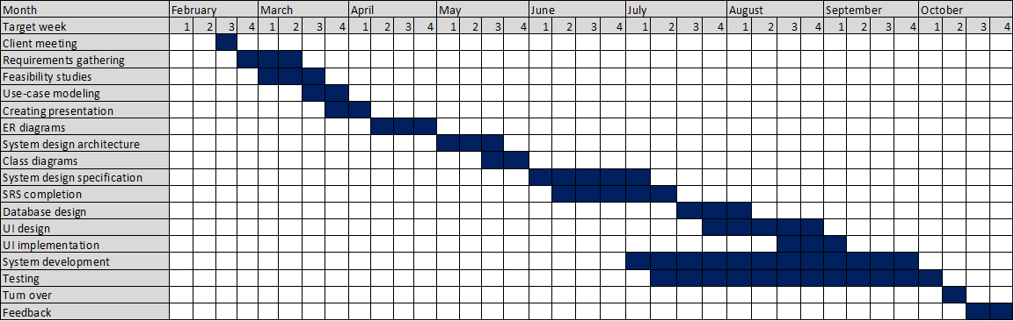

3.0 **Deliverables**

* A web based system to execute all tasks in a single platform.

**4. 0 Requirements**

**4.1. Stakeholders**

A stakeholder is a party that has an interest in a company and can either affect or be affected by the system. The stakeholders identified in this system are administrator, receptionist, teacher, student and parent.

**4. 1. 1. Administrator**

* Administrator has the power to appoint a receptionist.
* Admin can login and log out of the system as well as change the password to the system.
* Admin has the ability to view student and staff records.
* Admin is the only one who can create staff records as well as retrieve, update and delete all user records.
* Admin is responsible creating all user logins.
* He is also responsible for the confirmation of user accounts.
* Admin has the authority to add courses to the system as well as update and delete them.
* He can create class schedule, update them, delete them and post them.

**4. 1. 2. Receptionist**

* Receptionist can login and log out of the system.
* Receptionist is also responsible hall management that is allocating halls for classes according to class schedule, making sure the right halls are occupied at the right time, entering those details in the system as well as making arrangements for extra classes and new classes.
* Receptionist is responsible for payment management as well. That is making sure the student fees and teacher payments are collected for the month and making sure payment details are entered in the system.
* Receptionist handles notifications as well as. He has the ability to enter and send notifications that includes notifying students about changes in schedule, notifying about payments due and notifying parents about absent students.
* Receptionist is the one who has the ability to enter student records. Student details are entered to the system at the time of registration when the student first visits the institute.

**4. 1. 3. Student**

* Students can log in and log out of the online learning management system.
* Once the user account has been created the student can view and change the password to the account as well.
* Students can view class schedule and course details.
* Student is also able to view and download assignments posted online by the teacher of the course/courses he/she is following.
* Students are able to submit answers to the assignments. They can also view grades and teacher feedback to the uploaded answers as well as print them.
* Student can also receive notifications, mainly about the changes in class schedule and payment concerns.
* They can also view notices in the online learning management system.

**4. 1. 4. Teacher**

* Teacher can also login and log out of the learning management system.
* Once the teacher’s account is created he/she can change the password to it.
* Teacher can also view class schedules and notices.
* Teacher can upload assignments, view and download student’s answers and upload grades and feedback.

**4. 1. 5. Parent**

* Parent in this system will only receive notifications about their children’s attendance. When a student is absent for an assigned class or late more than 30 minutes, parent/guardian will receive a text message alerting them.

**4. 2. Functional Requirements**

1. Login

2. Manage student records

3. Manage teacher/staff records

4. Create user logins

5. Manage user accounts

6. Change passwords

7. Manage class schedule

8. Hall management

9. Payment management

10. Sending notifications

11. Upload assignments

12. View and download assignments

13. Upload grades and feedback

14. View grades and feedback

15. Submit answers

16. Download answers

**4.3. Non-functional requirements**

* **User friendliness**

Our proposed web application is simple, easy to use, has a consistent user interface and has a responsive design. This will aid the users to interact with the system easily. This will also be a key factor to gain more attraction to the institute.

* **Security**

The web site should be secure since personal details of student and staff are maintained. Only authorized users can access and view this information. Also the payment details should be handled in a secure manner in order to eliminate any frauds. Since multiple user types interact with the system, in order to maintain the security, every user type must have access control when using the system.

* **Portability**

This system is responsive to mobile phones, tablets as well as desktop computers. The web application should be lightweight so that it can run on a variety of connection speeds. This will improve the portability of the system.

* **Performance**

Time that the system takes to send messages and notifications should be minimized. Also database updates between the backend server and the web application should be minimized. In addition to these features the system should be able to handle many users at any given time. Thus the performance of the system is managed.

* **Accuracy and reliability**

Our system guarantees the security and accuracy of the user records and details of payments.

**4. 4 . Use cases and use case diagrams**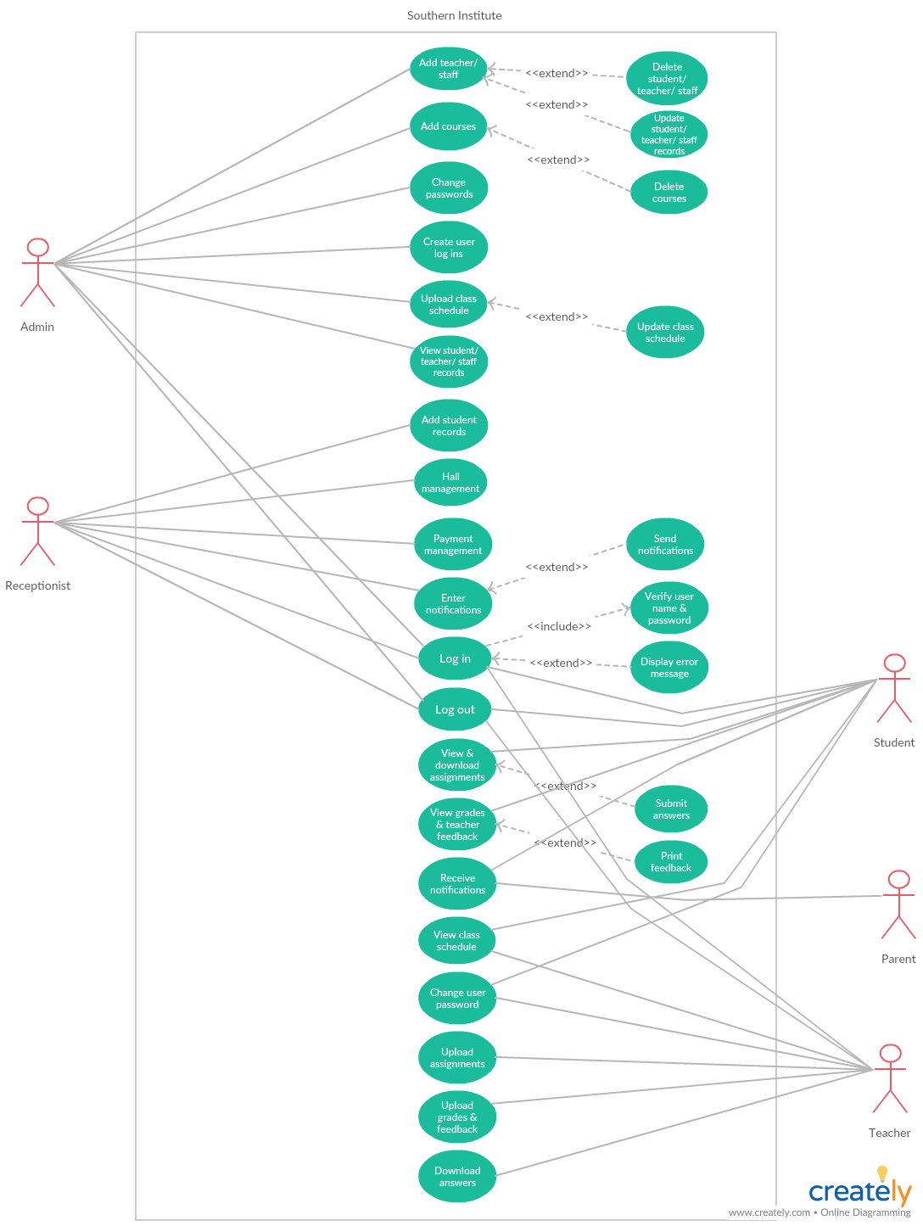

* Online learning management system

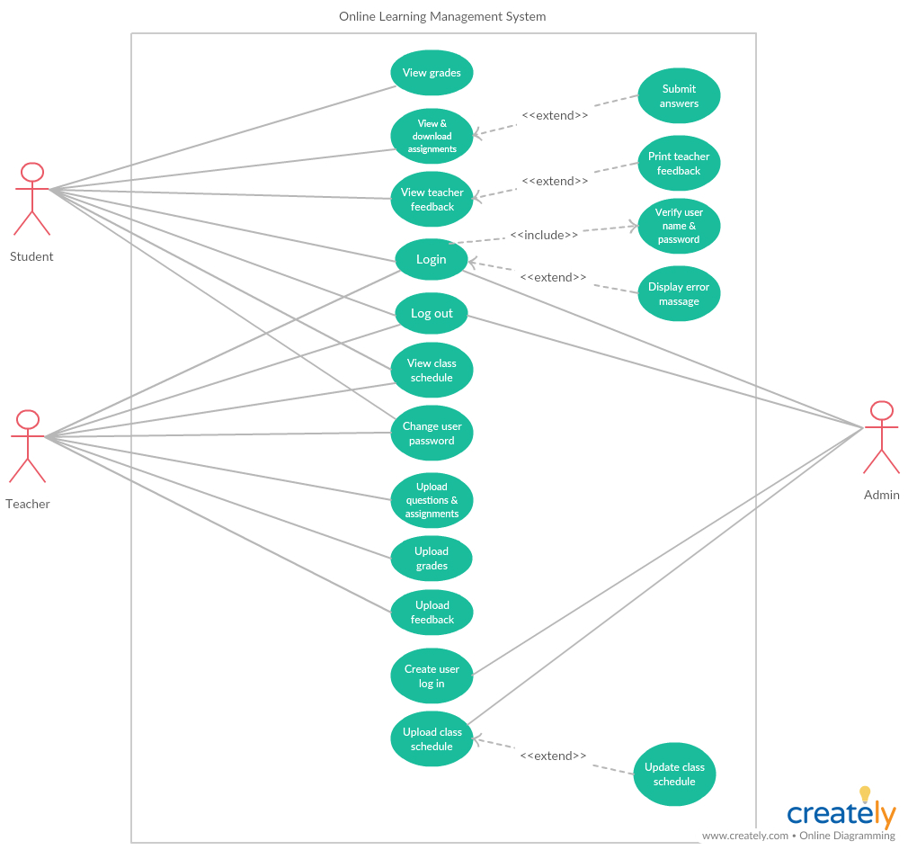

* Registration system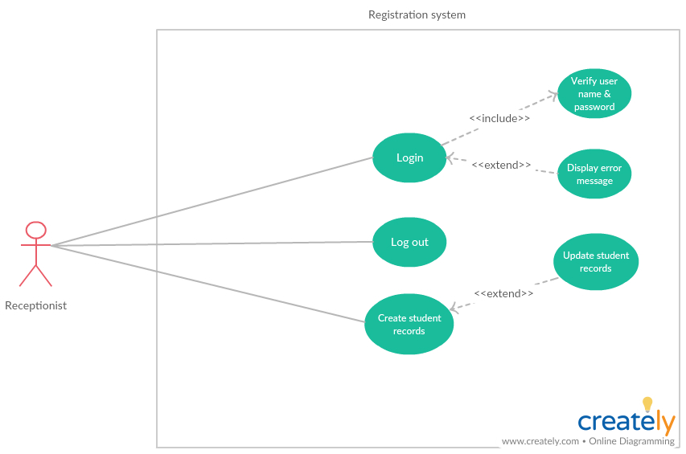
* Payment system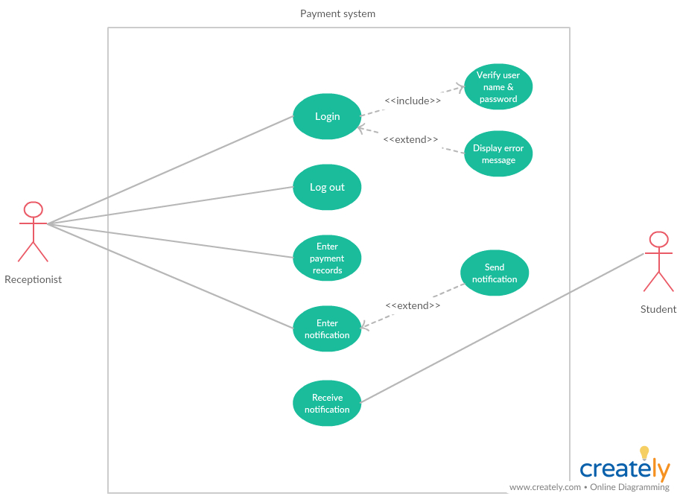
* Staff management system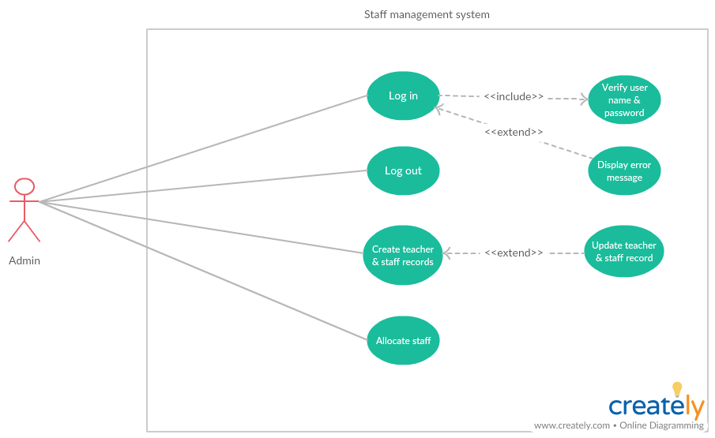
* Hall management system

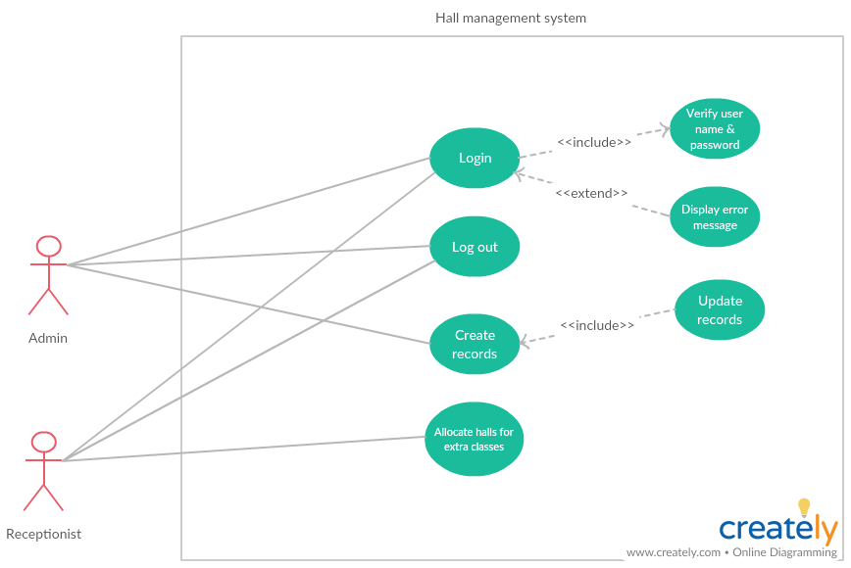

**4. 5. Use case narratives**

|  |  |
| --- | --- |
| Use case 01 | Login |
| Primary actor | Admin, Receptionist , Student, Teacher |
| Preconditions | Internet connection, User account |
| Main flow | 1. Go to home page of the System  2. Go to Login  3. Enter username and password  4. Click login button |
| Alternative flow | If username and password entered is not valid, display error message |
| Post conditions | User is redirected to the homepage of the system/Online learning management system, customized according to the user type |

|  |  |
| --- | --- |
| Use case 02 | Manage student records |
| Primary actor | Admin, Receptionist |
| Preconditions | Logged into the system |
| Main flow | 1. Go to Student registration  2. Select option  a. Add student  b. View student(Admin only)  c. Update student(Admin only)  d. Delete student(Admin only) |
| Alternative flow | None |
| Post conditions | None |

|  |  |
| --- | --- |
| Use case 03 | Manage teacher/staff records |
| Primary actor | Admin |
| Preconditions | Logged into the system |
| Main flow | 1. Go to staff management  2. Select option  a. Academic  b. Non-academic  3. Select option  a. Add  b. View  c. Update  d. Delete |
| Alternative flow | None |
| Post conditions | None |

|  |  |
| --- | --- |
| Use case 04 | Create user logins |
| Primary actor | Admin |
| Preconditions | Logged into the system |
| Main flow | 1. Log in to the system.  2. Click on Sign up button.  3. Enter student/teacher/receptionist username and password.  4. Click Submit. |
| Alternative flow | None |
| Post conditions | None |

|  |
| --- |
|  |
| |  |  | | --- | --- | | Use case 05 | Change passwords | | Primary actor | Admin, Student, Teacher | | Preconditions | Logged into the system | | Main flow | 1. Go to System/Online learning management system homepage  2. Click on change password  3. Type new password  4. Confirm password  5. Approve new user password(Admin only) | | Alternative flow | Password does not change until admin approves | | Post conditions | Change password |  |  |  | | --- | --- | | Use case 06 | Manage class schedule | | Primary actor | Admin | | Preconditions | Logged into the system | | Main flow | 1. Click on Class Schedule.  2. Update the class schedule.  3. Click Submit. | | Alternative flow | None | | Post conditions | None |  |  |  | | --- | --- | | Use case 07 | Hall management | | Primary actor | Receptionist | | Preconditions | Logged into the system | | Main flow | 1. Go to Hall Booking.  2. Enter date and time.  3. View free halls.  4. Book the hall. | | Alternative flow | None | | Post conditions | None |  |  |  | | --- | --- | | Use case 08 | Payment management | | Primary actor | Receptionist | | Preconditions | Logged into the system | | Main flow | 1. Read the student's barcode.  2. View student payment details.  3. Mark student payment.  4. Notify students to make payments.  5. Calculate and view the income. | | Alternative flow | None | | Post conditions | None |  |  |  | | --- | --- | | Use case 09 | Sending notifications | | Primary actor | Receptionist | | Preconditions | Logged into the system | | Main flow | 1. Click the Notifications tab.  2. Enter the notification. | | Alternative flow | None | | Post conditions | None |  |  |  | | --- | --- | | Use case 10 | Upload assignments | | Primary actor | Teacher | | Preconditions | Logged into Online learning management system | | Main flow | 1. Go to Assignments  2. Select Upload File  3. Select the file to upload  4. Click Submit button | | Alternative flow | None | | Post conditions | None |  |  |  | | --- | --- | | Use case 11 | View and download assignments | | Primary actor | Student | | Preconditions | Logged into Online learning management system | | Main flow | 1. Go to Assignments  2. Click on the assignment to view  3. Click on Download button | | Alternative flow | None | | Post conditions | None |      |  |  | | --- | --- | | Use case 12 | Upload grades and feedback | | Primary actor | Teacher | | Preconditions | Logged into Online learning management system | | Main flow | 1. Go to Feedback  2. Select Upload File  3. Select the file to upload  4. Click Submit button | | Alternative flow | None | | Post conditions | None |  |  |  | | --- | --- | | Use case 13 | View grades and feedback | | Primary actor | Student | | Preconditions | Logged into Online learning management system | | Main flow | 1. Go to Assignments  2. Select feedback file  3. Click on file to view grades/feedback | | Alternative flow | None | | Post conditions | None |  |  |  | | --- | --- | | Use case 14 | Submit answers | | Primary actor | Student | | Preconditions | Logged into Online learning management system | | Main flow | 1. Go to Assignments  2. Select submission link  3. Select the file to submit  4. Click on Submit button | | Alternative flow | None | | Post conditions | None |  |  |  | | --- | --- | | Use case 15 | Download answers | | Primary actor | Teacher | | Preconditions | Logged into Online learning management system | | Main flow | 1. Go to assignments.  2. Select the assignment link.  3. Select the student.  4. Select the submission file.  5. Click download. | | Alternative flow | None | | Post conditions | None |   **5.0 Proposed system architecture**  **5.1. High Level Architecture (Three-tier architecture)**  We have chosen Three-Tier Architecture as our software architecture. It consists of Presentation Tier, Application Tier and Data Tier. It allows any one of the three tiers to be upgraded or replaced independently. |
|  |
|  |
|  |
| **5. 2. Layers and responsibilities**  Three-tier architecture has three layers as described below.  5.2.1. Presentation Tier  The presentation-tier is basically the front-end of the system. Admin, Student, Teacher and Receptionist will interact with this layer. It is built using HTML, CSS, JavaScript, jQuery and Bootstrap and is accessible through a web browser.  Static web pages within our system are, About us page, Time Table page and Contact Us page. Since the users have different access rights, they will gain access to the system accordingly once they have logged into the system. The system users will be redirected as shown below after successfully logging into the system  Admin/Owner - Administrator Homepage  Receptionist -Receptionist Homepage  Student -Student Homepage  Teacher -Teacher Homepage  Depending on the authorization level, users will gain access to other user interfaces such as Notification, Registration, Courses, Hall Management, Payment, Attendance and Virtual Learning Environment.  5.2.2. Application Tier  The application-tier will interact with the presentation-tier. This layer contains the functional business logic of the system which are Hall management module, Course module, Virtual Learning Environment module, payment management module, attendance module, notification module, registration module. This tier will be developed using PHP.  The components and their responsibilities are given below for the core functionalities identified in the application-tier.   |  |  | | --- | --- | | Module | Main Functionalities | | Authentication | * Login to the system. * Logout of the system. * Authenticate users based on username and password. | | Hall Management | * Allocate Halls with hall number and course. * View Hall details. * Delete Halls for the courses. * Edit Hall details. | | Notification | * Send messages for parents when students are absent to the class and coming late to the class. * Send general notices in the institute. | | Attendance | * Can select number of students who are absent to the class. * Can select number of students who are late to the class. | | Registration | * Add students, teachers and staff details to the system. * View students, teachers and staff detail. | | Payment Management | * Handle cash payments of the institute * Handle the class fees of the students. * Handle monthly cash payments in the institute. | | Virtual Learning Environment | * Can connect student teachers online. * Add course details. * View course details. * Add course materials. * View course materials. * Add Assessments to the students. * Upload answers to the questions. * Add marks for the subject test. * View marks for the subject test. | | Course | * View Courses with time, grade and teachers. * Edit the courses. * Remove courses in the institute. |   5.2.3. Data Tier  Application-tier will be interacting with the data-tier. This data-tier comprises of the database of our system and is used to store and retrieve data. MYSQL is the DBMS used for this system.  **5.3. Component Interactions**  Shown below is a block diagram to describe the application-tier within our system. This depicts the components and component interactions that we have identified. |
|  |
| **6.0 SYSTEM DESIGN**  **6.1. Class Diagram**    **6.2. Sequence Diagrams**  **6.2.1. Login**  **6.2.2. Manage Class Schedule**    **6.2.3. Manage user records**    **6.2.4. Sending notifications**    **6.2.5. Upload grades and feedback**    **6.2.6. Upload assignments**    **6.2.7. View grades and feedback**    **6.2.8. View and download assignments** |
|  |
|  |
| **6.3. Activity Diagrams**  6.3.1. Student Registration |

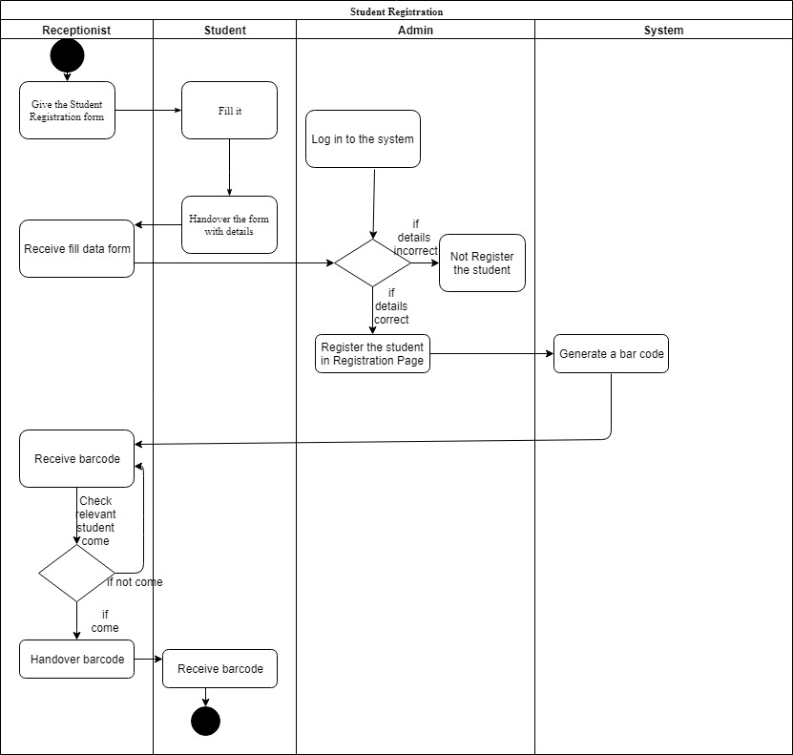

6.3.2. Mark the attendence,payment and Receiving notifications .

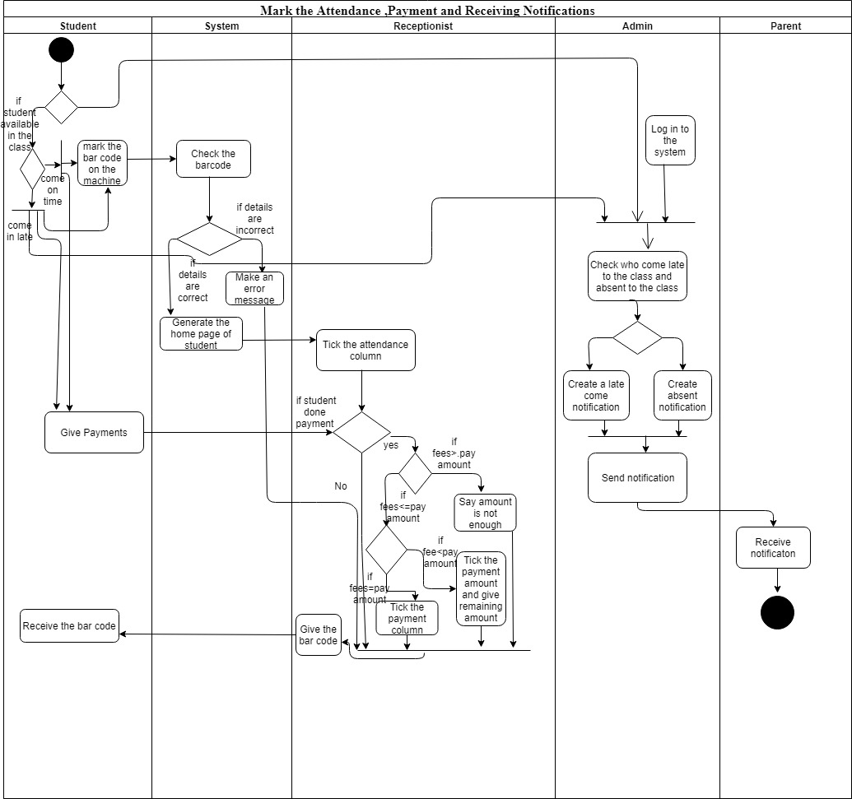

6.3.3. Virtual Learning Environment (VLE)

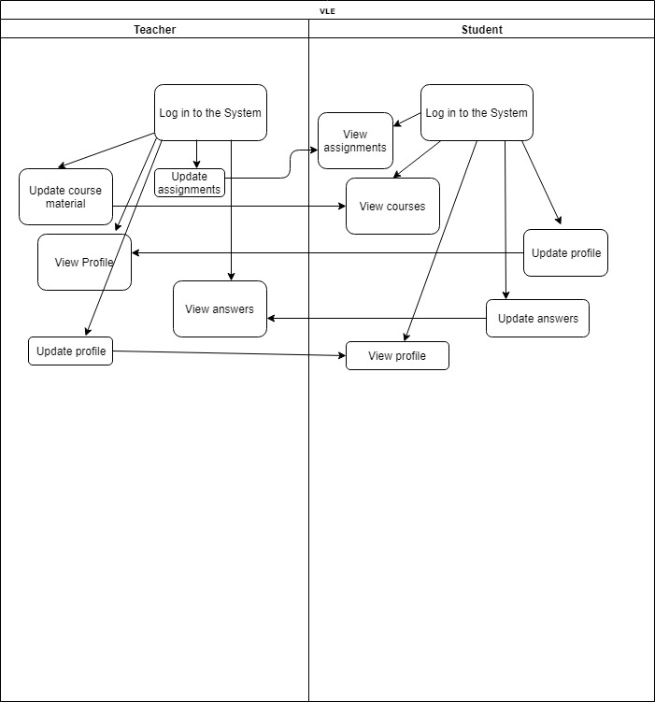

**6.4. Database Design**

**6.4.1. Entity Relationship Diagram (ERD)**

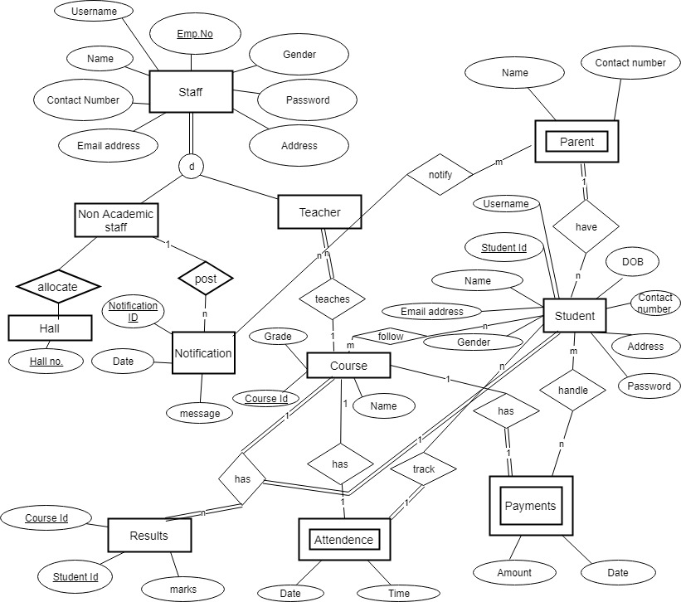

Assumptions:

* Student are registered by the admin at begin.

|  |
| --- |
| 8**.0 INTERFACES**  **8.1. User Interface Flow Diagrams**            **8.2. User Interface Mockups**  Some of the mockups as shown below,  Home Page of the Southern Institute |
|  |
| Admin Home Page |
| Receptionist Home Page    Student Home Page |
| Teacher Home Page |
|  |
|  |
|  |
|  |

|  |  |
| --- | --- |
|  |  |
|  |  |
|  |  |
|  |  |
|  |  |
|  |  |

|  |  |
| --- | --- |
|  |  |
|  |  |
|  |  |
|  |  |
|  |  |
|  |  |